The Elemental Yoga School
Application Form


Please make sure you answer all the
relevant Questions :)

Please take your time to fill out this form, and where past
medical conditions are relevant, explain as much as you can.
If you simply write one word answers it may not help us to make
sure this course is right for you.
Please return this form electronically, to

jai.c.salt@gmail.com
PLEASE HIGHLIGHT THE TRAINING YOU ARE APPLYING FOR:

2019

The 200Hr Yoga Teacher Training, January 30TH –
February 20th, 2019 IN Bali

THE 200HR YOGA TEACHER TRAINING AND PREGNANCY YOGA TEACHER TRAINING COURSE, JANUARY 30TH – FEBRUARY 28TH, 2019 IN BALI

The 85Hr Elemental Pregnancy Yoga teacher Training
February 20th , – 28th 2019, in balI

The 200Hr Yoga Teacher Training, September 27TH – october 18th, 2019 IN Bali

The 300Hr Yoga therapy Teacher Training, October 22TH – november 19th, 2019 IN Bali

The 500Hr Yoga therapy Teacher Training, SEPTEMBER 27TH – november 19th, 2019 IN Bali

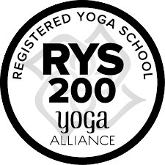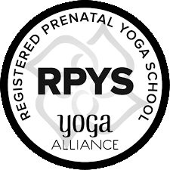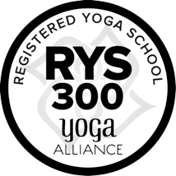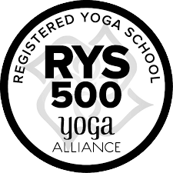

1. PERSONAL INFORMATION
Full Name:

Gender:

Date of Birth:

Home Phone:

Cell Phone:

E-mail:

Skype:

Address:

Street:

City:

Country:

Please take a moment to share what attracted you to this
Elemental Yoga School Training.

How long have you been practicing Yoga?

Which style(s) of Yoga do you practice regularly?

How many hours do you practice per week?

If you are already a certified Yoga Teacher

How long have you been teaching yoga?

What level of Qualification do you hold as a Yoga Teacher? Please
provide the names of your principal teachers or schools from where
you have been qualified.

What style of Yoga do you teach?

Do you teach one-to-one classes?

Have you been working in any Healing Arts as a therapist or healer?

Do you have any experience in other 5 Element forms of medicine, or
counselling through other techniques? Zen Shiatsu, Holistic
Kinesiology, Acupuncture, Macrobiotics, Ayurvedic Nutrition, or
Coaching, Psychology, CBT, Art Therapy Etc.

3.. HEALTH INFORMATION (Confidential)
If you are under medical treatment or supervision, please tell us
about it as thoroughly as you can.

If you have any chronic physical impairment (e.g., spinal or back
pain, limited physical movement, poor vision or hearing etc), please
tell us what is the nature and extent of your health challenges?

If you have had a recent history of fatigue, emotional collapse, or
major trauma please tell us about your experience and where you are in
your recovery.

Do you have any physical injury or condition that prevents you from
practicing daily?

If you are currently receiving counselling, coaching, psychotherapy,
psychiatric treatment, or medication for any mental imbalances,
please tell us about the history and processes you are in currently.

If you have ever been hospitalized or received psychiatric treatment,
when did this occur and for which condition(s)?

Do you have any communicable diseases?

During the past three years have you been addicted to or excessively
using drugs or alcohol? If so, please give us an overview of this
experience.

If you are using any prescription medication, please indicate the
type, dosage, and frequency of intake

Would you consider yourself to be in a fit state to undertake the course with all its personal development aspects?

Please tell us your personal reasons for attending the Elemental
Yoga Therapy Teacher Training Course?

4. EMERGENCY CONTACTS
(Where Applicable)

Name: Phone:

Physician: Phone:

Therapist: Phone:

5. ADDITIONAL INFORMATION

If you wish to share any additional information here, please feel
free to communicate anything you feel may be relevant to your
taking part in this program

6. REFUND POLICY

A Deposit of 500 Euros is needed to ensure your
Reservation for a place in The 200 Hr or 300 Hr Elemental Yoga Therapy Teacher Training. A Deposit of 1000 Euros is needed to ensure your Reservation for a place in The 500 Hr Elemental Yoga Therapy Teacher Training.
All remaining Fees are due 60 days prior to
the commencement date of the Training.
Within 60 days of the start date, no Refund or Credit
will be given. Once the Training begins, no Refund or
Credit will be given.
The Deposit and Registration Fee are non-refundable.

Please add a recent photograph in this box
(Double click on the picture below and then choose ‘change picture’ in the Microsoft word software ☺) 

This Teacher Training course is run in the spirit of
Ashram life

there are clear boundaries around the
prohibition of consuming any toxic substances,
using inappropriate language, or engaging in
sexual activity with other students

This will be discussed at the beginning of the training program

I look ForwARD TO MEETING YOU AND I AM ALWAYS
AVAILABLE TO ANSWER ANY QUESTIONS OR DISCUSS ANY
CONCERNS YOU MAY HAVE ABOUT THE
TRAINING PROGRAM.

It is a very unique and wonderful experience and I wish you will join us in Bali ☺

Please sign AND Date this Application and return it to jai.c.salt@gmail.com for confidentiality
DD/MM/YY

Signature:



